Ahmad Dangana  
010240383

**Task 1**

* Create a script file task1.sh: 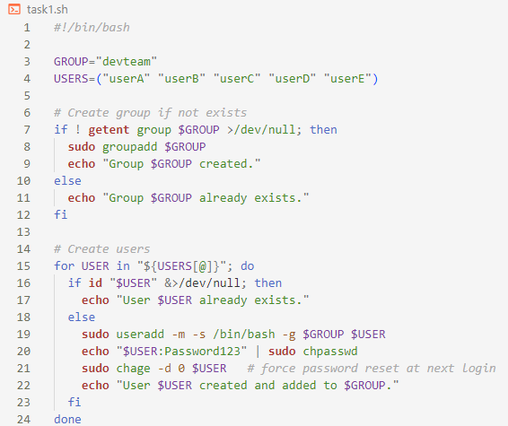
* Upload the file to the server then reconnect 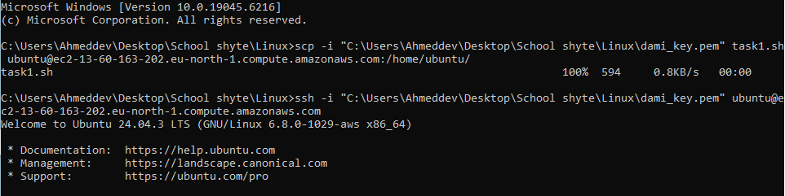
* Confirm the existence of the file then make it executable using chmod +x task1.sh and run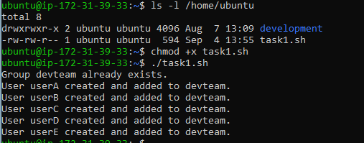

Task 2:

* Create the shared directory with sudo mkdir /shared_data



* Set group ownership to devteam



* Set group permissions (read + write, deleting other users files not allowed)



* Create an extra user outside the group

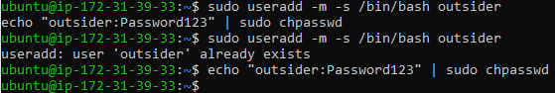

* Grant outsider read-only access via ACL



* Confirm it worked

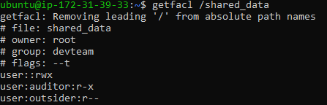

Task 3:

* Create document roots and add sample index

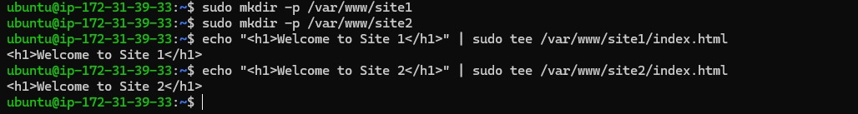

* Configure virtual hosts for both sites one after the other



Add this for each

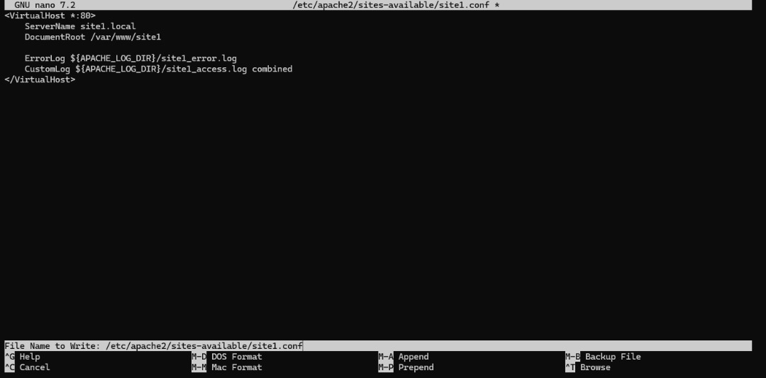

* Enable the sites

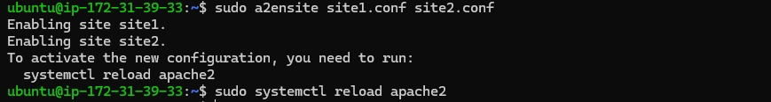

* Update local host files in the PC



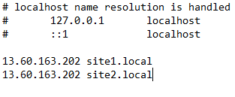

* Test in browser

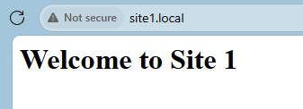

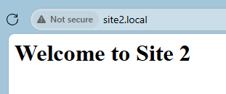

Task 4:

* Enable SSL module in Apache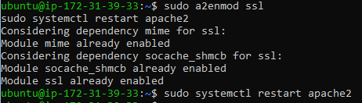
* Create directories for certificate



* Generate a self-signed SSL certificate

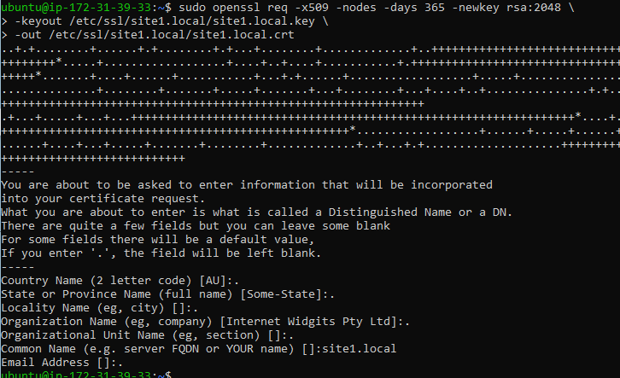

* Create an HTTPS Virtual Host for site1



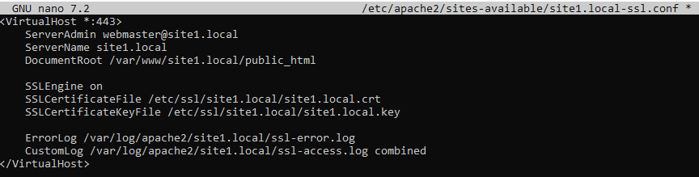

* Enable the SSL site

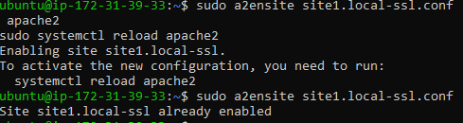

Task 5:

* Install MySQL Server

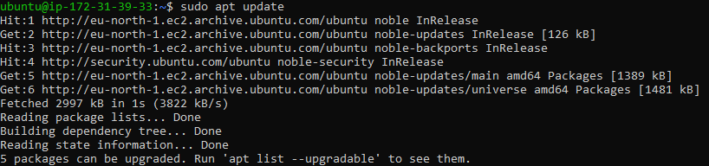

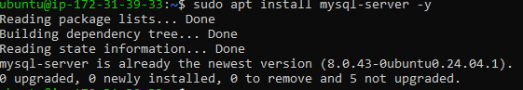

* Configure MySQL to Listen on All Interfaces





* Restart MySQL



* Login to MySQL



* Create DATABASE projectdb



* Create a Least-Privilege User







Task 6:

* Enable UFW



* Allow my only specific ip range

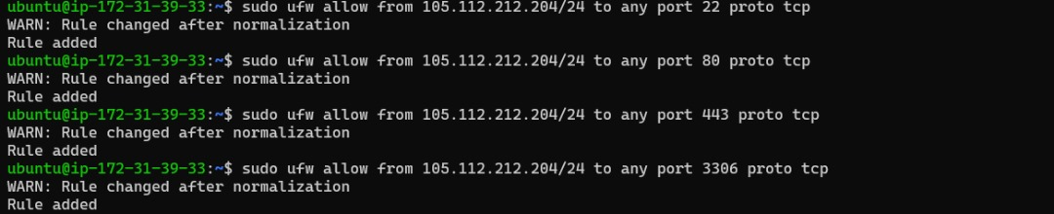

* Confirm UFW status

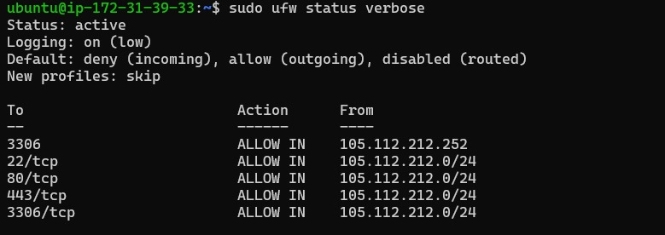

Task 7:

* Open the script file in an editor and add the script content



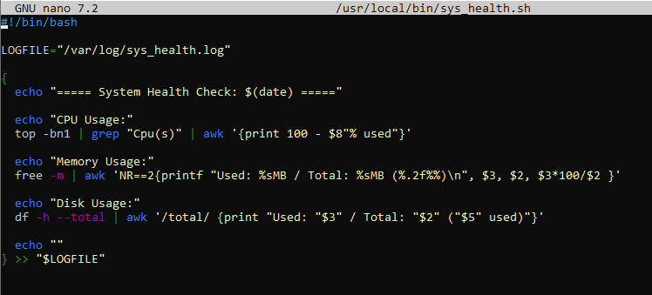

* Make the script executable



* Test run the script



Check if the log file was created

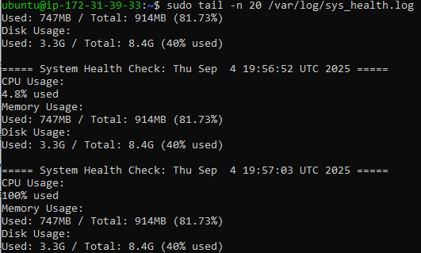

* Set it as a cron job (runs every 5 mins)



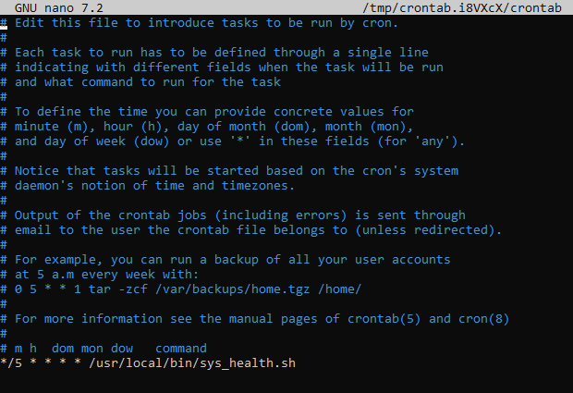

Task 8:

* Create a Logrotate Config File and add script content



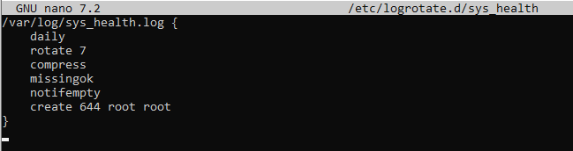

* Test the Logrotate Configuration

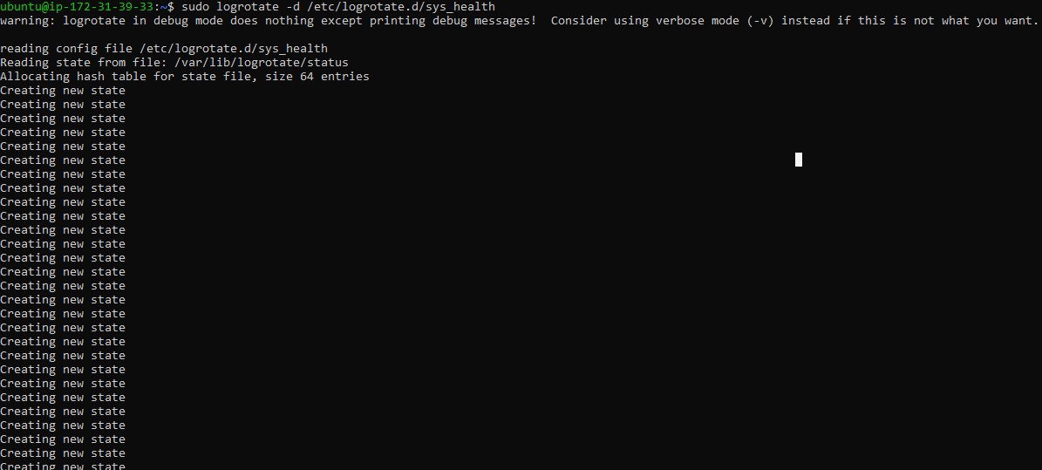

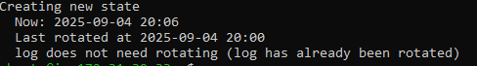

* Verify Rotation



Task 9:

* Install Bind9



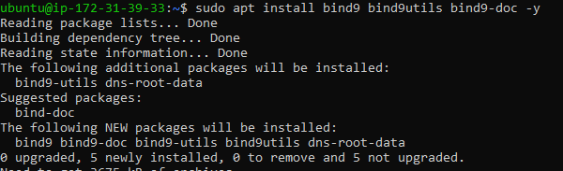

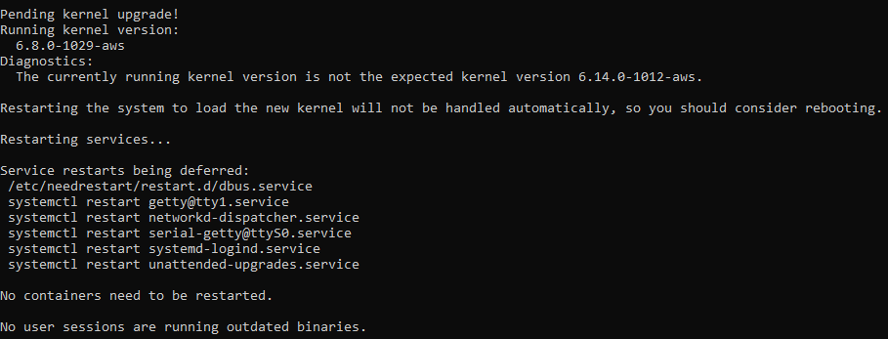

* Enable and start BIND9





* Check the status after starting

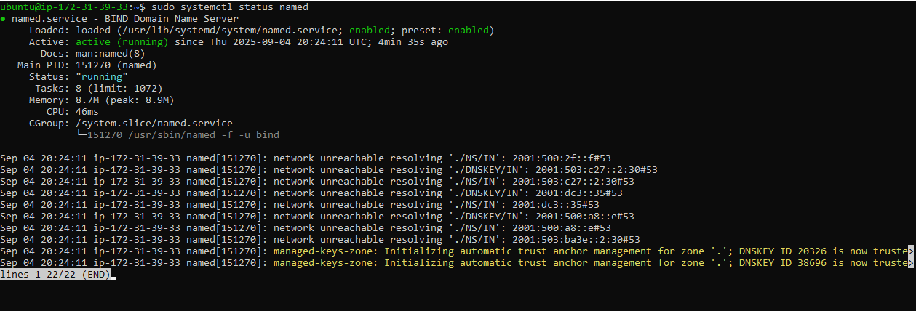

* Configure as a Caching DNS Server by editing the options with listen-on { any; }; and

allow-query { any; };



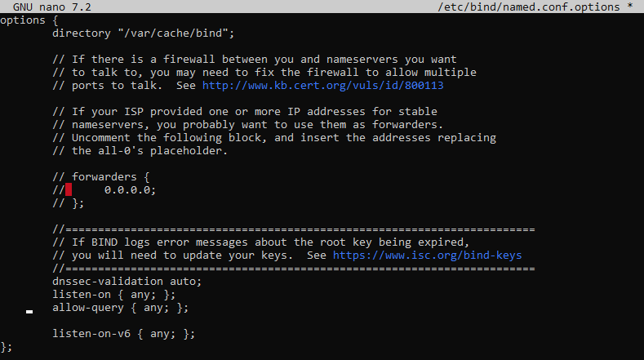

* Restart BIND9



* Define a New Zone for myuniversity.local

Edit zone configuration



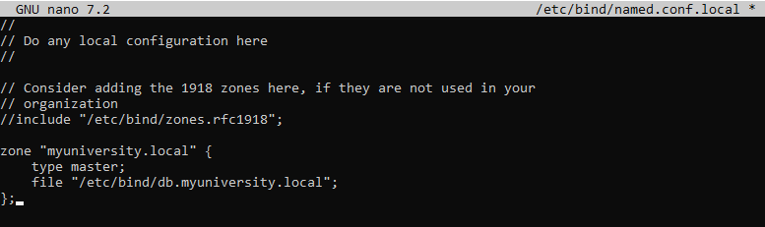

* Create the Zone File



* Edit the new file

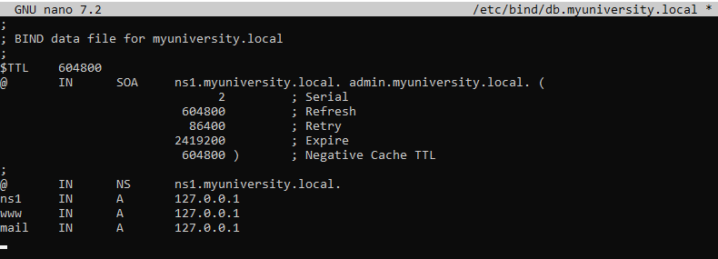

* Check Config & Restart BIND9







* Test DNS Resolution

Edit nameserver in /etc/resolv.conf:



Test Resolution:

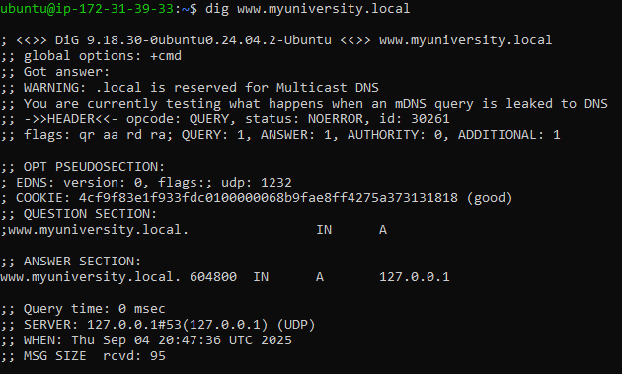

Task 10:

* Open the SSH server config file:



* Edit SSH Configuration

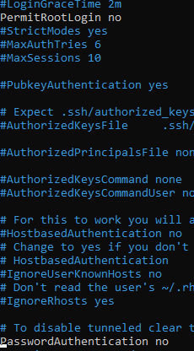

* Restart SSH



Task 11:

* Create a Simple Script



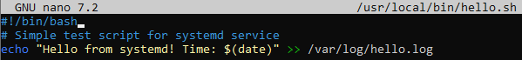

* Make it executable



* Create a Systemd Service File



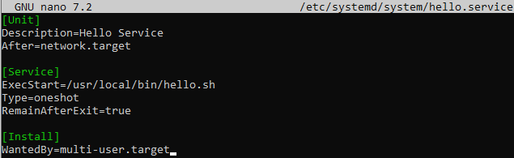

* Reload Systemd & Enable Service



* Verify Service

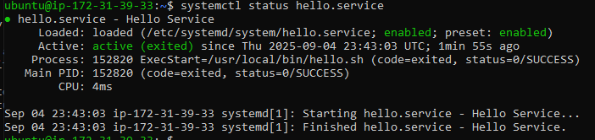

Task 12:

* An AWS EC2 instance, your root disk is usually small (8 GB) so I create a Fake Disk (Loopback File)



* Turn It Into a Block Device and confirm

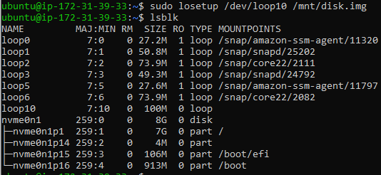

* Partition the Disk

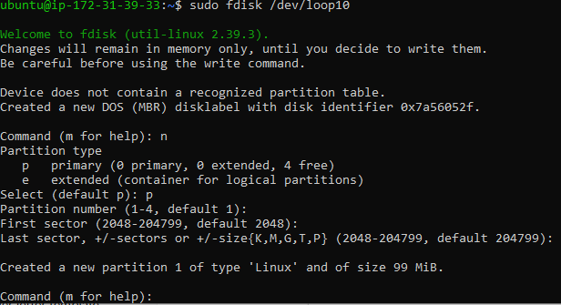

* Refresh Partition Table and check for new partition

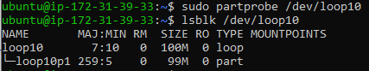

* Format Partition

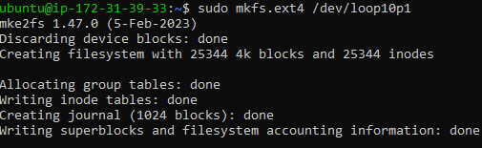

* Mount Partition

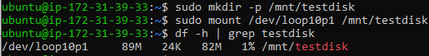

* Get UUID and add to /etc/fstab for persistence

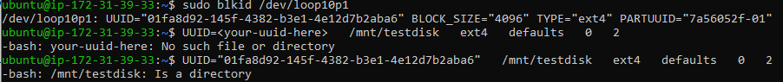

Task 13:

* Install Postfix and configure during installation

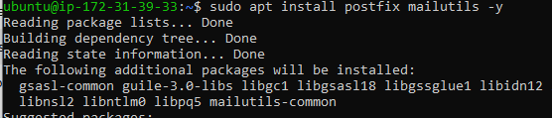

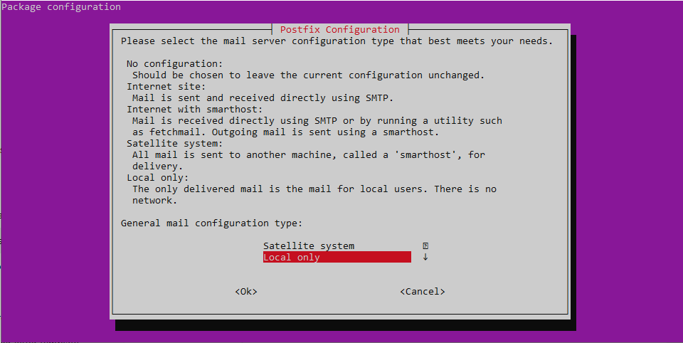

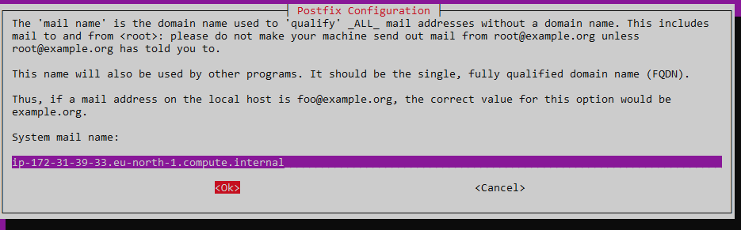

* Verify Postfix is Running

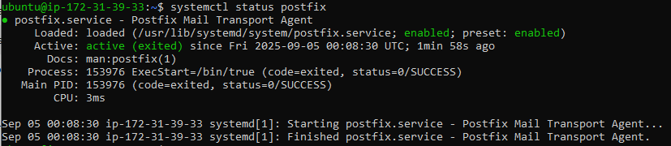

* Send a Test Mail and check user inbox

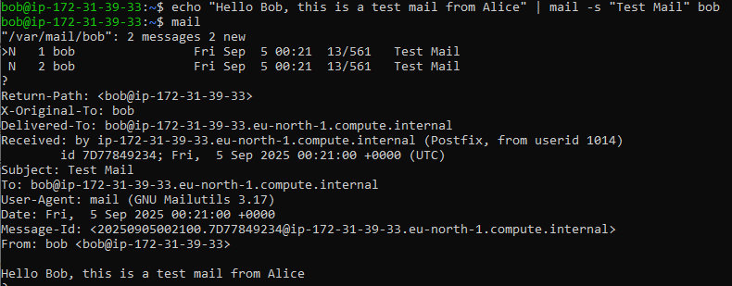

Task 14:

* Create Backup Directory



* Create the Script



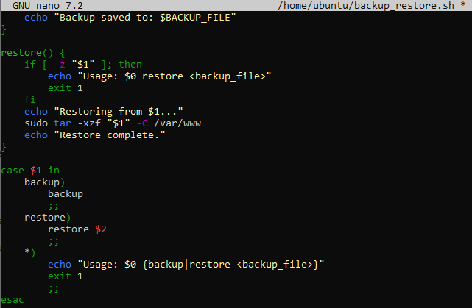

* Make It Executable



* Run script and check backups

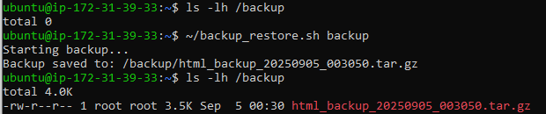

* Simulate data loss



* Restore from backup



Task 15:

* Install Docker

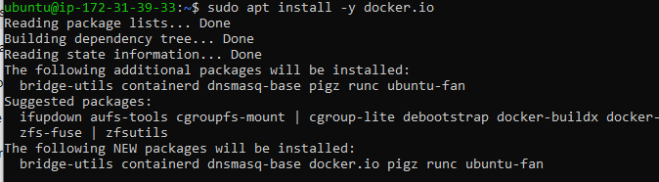

* Enable, start Docker and check version

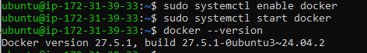

* Run Nginx Container on Port 8080

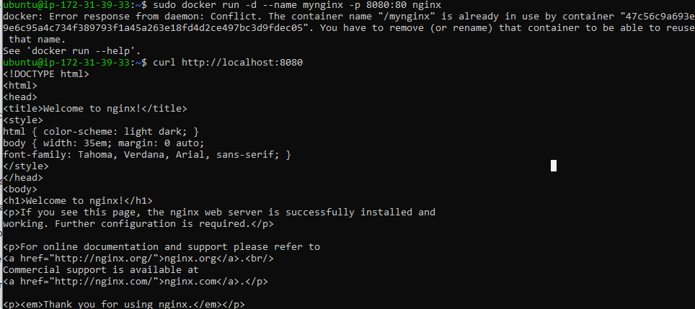

* Verify Container is Running



* Test Nginx

